**GoJek story – Indonesia’s Unicorn Journey | Greenhouse**

[greenhouse.co](https://greenhouse.co/blog/gojek-story-indonesias-unicorn-journey/)

6-8 minutes

17 May 2018 |

9 Minutes read time

[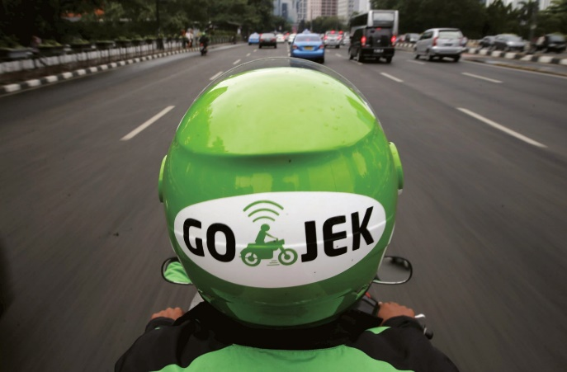](about:reader?url=https%3A%2F%2Fgreenhouse.co%2Fblog%2Fgojek-story-indonesias-unicorn-journey%2F)

Key takeaways:

* Realized difficulties faced by drivers while waiting for riders
* Service minded – wanting to help people find lively hoods
* Better understanding of local market – largely middle class & lower class population, traffic congestion,
* Perseverance: Continued to interact with drivers and riders
* Evolution into a platform for many other things: Bike, trucks, Food delivery, grocery ordering,

**What is Indonesia’s contribution to the world of startups?**

Are there any pure and homegrown Indonesian startup companies?

Did Indonesian startup ecosystem create truly global startup companies that have become well-known global unicorns?

These are some most important questions that countless people from Indonesia and others from nearby areas ask analysts who are well informed about the world of business. Indonesia is not behind when it comes to competing with other nations in the domain of startups. Indonesia is the home to innumerable homegrown startups that are excellent and truly efficient.

However, one startup has outpaced all other startups to become a truly global business firm and the first Indonesian unicorn! The story of Go-Jek is classical and legendary in the domain of startups business.

Learning and understanding Go-Jek is truly inspiring and encouraging because it is a company that represents a true “rags to riches” type of story that is told and retold in the world of competitive business.

**Local Startup Hero**

GO-JEK is a [local transport](https://www.go-jek.com/), logistical and payment startup, it was founded in 2010. It was originally a motorcycle rent for ride type of service. Now, it has evolved into a popular on-demand mobile platform, and an industry rated application maker. It also provides a wider variety of services like transportation, logistics, mobile payments, food delivery, and many other on-demand services.

Essentially a transport system, Go-Jek seeks to bring improvements to a large group of informal workers. Now, Go-JEK owns the largest fleet of motorcycles, cars, and trucks and it is Indonesia’s biggest non-governmental employment creator.

In fact, Go-Jek is Indonesia’s first formal member of startup ecosystem that sought to develop its minor business operations into larger entities. No wonder, Go-Jek’s corporate motto reflects its service motivated corporate goals: speed, innovation, and social impact. Go-Jek’s noble corporate goals ensure that drivers who join it would see increases in their basic income that eventually makes them self-sufficient citizens.

**What is so special about Go-Jek?**

Like [Uber](https://www.uber.com/en-ID/), ride-hailing behemoth from USA, Go-Jek also resembles similar objectives and earning models. However, Go-Jek understands the local market, culture, and tradition. This provides a competitive edge over Uber.

The globalized Uber model uses cars as its main business driver, while Go-Jek depends on scooters and motorcycles for its entrepreneurship. Secondly, in a developing country like Indonesia, people can easily buy and own scooters and motorcycles because it’s way more affordable than four-wheelers.

In other words, Indonesia’s large indigenous supply of riders and drivers makes Go-Jek lead the transport industry largely. In essence, Indonesia’s Go-Jek was far more alert and smarter than Uber, whose understanding of the local market is not as good and efficient as that of Go-Jek’s. Seemingly, Go-Jek could scale its business operations rapidly when compared to Uber, who seemed to struggle in a market that is largely middle and lower level income earners.

Another important issue that helps Go-Jek to seize an advantage over Uber is that most of the cities in Indonesia are highly congested, and the traffic is often chaotic. Under such a situation, scooters and motorcycles can easily negotiate peak hour traffic far more efficiently than cars. Therefore, the transport solution offered by Go-Jek is flexible and hassle-free. Third, Go-Jek’s innovative integration of different, personalized services into a seamless creation of an Android application.

**Go-Jek’s personalized apps allow you to:**

1. Organize and order pickup by scooter or motorcycles
2. Book a lorry or truck to transport personal luggage and boxes
3. Book movie tickets
4. Order groceries from online stores
5. Order personalized services delivered like beautician and massage

Indonesia’s startup ecosystem is very robust and stable because of its proximity to local customs and traditions. Go-Jek reputation’s testimony to Indonesia’s startup success is largely attributed to its innovativeness, corporate prudence, and very strong business ethics.

**The Go-Jek’s story retold**

Go-Jek’s story is rather very interesting. The founder Nadiem Makarim often used “ojek” (Motorbike taxi) before he became an entrepreneur. His frequent interaction with ojek drivers educated him about the difficulties faced while waiting for their customers. Similarly, people used to spend a lot of their time waiting for an ojek.

Eventually, Nadiem Makarim was able to convince both drivers and users to interact with each other through a smart application. Nadiem Makarim was the leader of the team developed the application to interconnect drivers and travellers.

**Started with just ten employees**

Initially, Go-jek started with just ten employees and a score of ojek drivers. The Go-Jek application was still unknown and people were hesitant to use it, because of many factors like opposition by local ojek riders and crippling governmental regulations.

Over time, frequent interactions with ojek drivers convinced them that there was an easy way to get customers for their ojek drive by using Go-jek mobile application. Although, there was a fierce resistance to this business in the early phases, many people starting accepting this as a great tool to hire ojeks. A significant opposition to this startup business movement came from the Ministry of Transport that once banned Go-Jek business.

Now, Go-Jek also offers several other services apart from ojek. Instant couriers transport and shopping services are some innovations that brought business closer to people’s home. Some other services offered to consumers include Go-Food, Go-Mart, Go-Glam, Go-Clean, Go-Massage, Go-Box, Go-Busway and Go-Tix.

**Global Unicorns Club**

Hitherto, Indonesia never had any noted business startups. However, Go-jek changed all these with their visionary ojek services. In addition, Go-jek’s ability to attract foreign investment has been hailed as the first real corporate move by global business analysts and thinkers.

A recent addition to the global club of unicorns, GoJek’s story is enduring and captivating to young startup business ventures of Indonesia. Go-Jek’s incessant unicorn movement may catalyze many other innovative startups to grow and display a higher level of corporate performance. Fundamentally, Go-Jek’s smart business acumen and corporate brilliance are the two main factors that could propel Indonesia’s startup business revolution.